**Final Project Report Template**

1. Introduction
   1. Project overviews
   2. Objectives
2. Project Initialization and Planning Phase
   1. Define Problem Statement
   2. Project Proposal (Proposed Solution)
   3. Initial Project Planning
3. Data Collection and Preprocessing Phase
   1. Data Collection Plan and Raw Data Sources Identified
   2. Data Quality Report
   3. Data Exploration and Preprocessing
4. Model Development Phase
   1. Feature Selection Report
   2. Model Selection Report
   3. Initial Model Training Code, Model Validation and Evaluation Report
5. Model Optimization and Tuning Phase
   1. Hyperparameter Tuning Documentation
   2. Performance Metrics Comparison Report
   3. Final Model Selection Justification
6. Results
   1. Output Screenshots
7. Advantages & Disadvantages
8. Conclusion
9. Future Scope
10. Appendix
    1. Source Code
    2. GitHub & Project Demo Link

**1. INTRODUCTION**

**1.1 Project Overview**

The 'Smart Lender: Applicant Credibility Prediction for Loan Approval' project aims to assist banks and financial institutions in predicting whether a loan applicant is likely to be eligible for loan approval based on their financial profile. The project leverages machine learning models to analyze key factors, such as income, credit history, loan amount, and more, to determine the likelihood of an applicant's loan approval.

This solution helps banks reduce risks associated with non-performing loans and make more informed lending decisions. By predicting the credibility of applicants, the model provides a faster and more efficient process for loan approval, benefiting both banks and customers. The system can be scaled to work with multiple loan types, making it adaptable to different banking needs.

**1.2 Objectives**

The main objectives of this project are:

- Accurate Loan Eligibility Prediction: Build a machine learning model capable of predicting whether an applicant will likely default or be eligible for a loan.

- Minimize Credit Risk: Reduce financial losses for banks by identifying potential defaulters, thereby improving the loan approval process and ensuring only credible applicants receive loans.

- Improve Decision-making Process: Provide a system that assists in the fast, accurate, and reliable decision-making process for loan approval.

- Increase Efficiency: Automate the loan approval process, reducing manual intervention, speeding up decision times, and improving customer satisfaction.

**2. Project Initialization and Planning Phase**

**2.1 Define Problem Statement**

|  |  |
| --- | --- |
| Date | 01 October 2024 |
| Team ID | LTVIP2024TMID24947 |
| Project Name | SmartLender - Applicant Credibility Prediction for Loan Approval |
| Maximum Marks | 3 Marks |

**Define Problem Statements (Customer Problem Statement Template):**

**Financial institutions** and **lending companies** struggle with making quick, reliable, and unbiased decisions when evaluating loan applicants. With an increasing volume of loan applications, manual review processes often lead to delays, errors, and inconsistent approvals. Lenders need to identify credible applicants with a high likelihood of timely repayment to minimize risk and defaults.

Applicants are also frustrated with the slow and opaque loan approval process. They need quicker decisions and more transparency about how their eligibility is evaluated.

**SmartLender** aims to solve this problem by providing an automated system that evaluates applicants based on multiple factors like their number of dependents, education level, employment status, loan amount, loan term, CIBIL score, and assets. This model will ensure fast, fair, and accurate loan approval decisions, helping both the lender and applicant experience a smoother loan approval process.

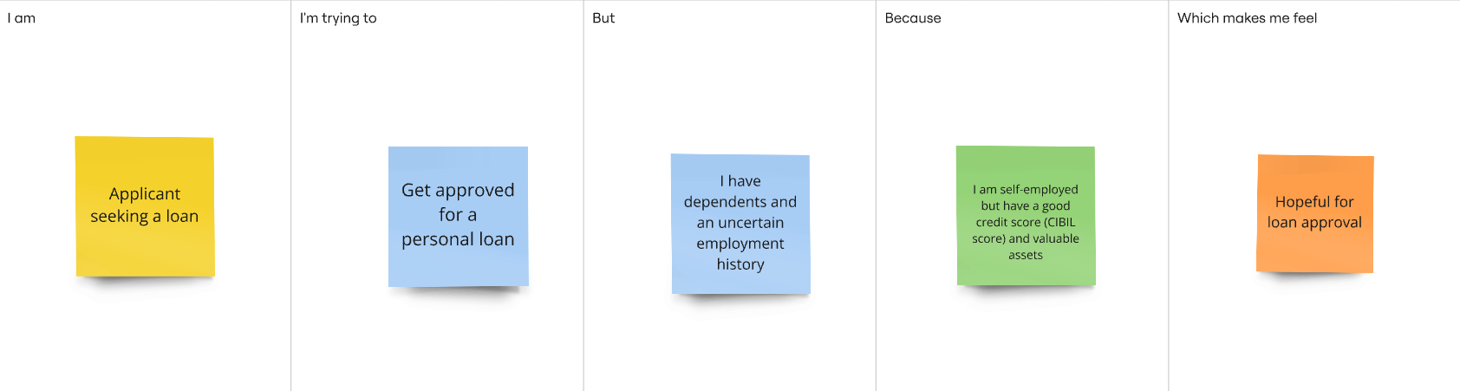

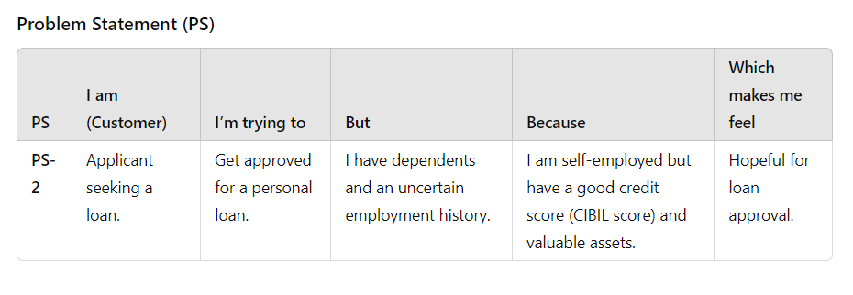

**2.2 Project Proposal (Proposed Solution)**

|  |  |
| --- | --- |
| Date | 01 October 2024 |
| Team ID | LTVIP2024TMID24947 |
| Project Title | SmartLender - Applicant Credibility Prediction for Loan Approval |
| Maximum Marks | 3 Marks |

Project Proposal (Proposed Solution) report

The proposal report aims to transform loan approval using machine learning, boosting efficiency and accuracy. It tackles system inefficiencies, promising better operations, reduced risks, and happier customers. Key features include a machine learning-based credit model and real-time decision-making.

|  |  |
| --- | --- |
| Project Overview | |
| Objective | The primary objective is to revolutionize the loan approval process by implementing advanced machine learning techniques, ensuring faster and more accurate assessments. |
| Scope | The project comprehensively assesses and enhances the loan approval process, incorporating machine learning for a more robust and efficient system. |
| Problem Statement | |
| Description | Addressing inaccuracies and inefficiencies in the current loan approval system adversely affects operational efficiency and customer satisfaction. |
| Impact | Solving these issues will result in improved operational efficiency, reduced risks, and an overall enhancement in the lending process, contributing to customer satisfaction and organizational success. |
| Proposed Solution | |
| Approach | Employing machine learning techniques to analyze and predict creditworthiness, creating a dynamic and adaptable loan approval system. |
| Key Features | - Implementation of a machine learning-based credit assessment model. |

|  |  |
| --- | --- |
| Key Features | * Real-time decision-making for quicker loan approvals. * Continuous learning to adapt to evolving financial landscapes. |

Resource Requirements

|  |  |  |
| --- | --- | --- |
| Resource Type | Description | Specification/Allocation |
| Hardware | | |
| Computing Resources | CPU/GPU specifications, number of cores | T4 GPU |
| Memory | RAM specifications | 8 GB |
| Storage | Disk space for data, models, and logs | 1 TB SSD |
| Software | | |
| Frameworks | Python frameworks | Flask |
| Libraries | Additional libraries | scikit-learn, pandas, numpy, matplotlib, seaborn |
| Development Environment | IDE | Google colab Notebook, vscode |
| Data | | |
| Data | Source, size, format | Kaggle dataset, 4269, csv |

**2.3.** **Initial Project Planning**

|  |  |
| --- | --- |
| Date | 28-09-2024 |
| Team ID | LTVIP2024TMID24947 |
| Project Name | SmartLender - Applicant Credibility Prediction for Loan Approval |
| Maximum Marks | 4 Marks |

**Product Backlog, Task Schedule, and Estimation**

Use the below template to create a product backlog and Task schedule

|  |  |  |  |  |  |  |  |
| --- | --- | --- | --- | --- | --- | --- | --- |
| TASKS | **Functional**  **Requirement (Epic)** | **User Story**  **Number/**  **Task no** | **User Story / Task** | **Priority** | **Team**  **Members** | **Task Start Date** | **Task End Date (Planned)** |
| Task-1 | Data Collection | TSk-275328 | Download the dataset | Low | nivas | 2024/09/20 | 2024/09/22 |
| Task-2 | Visualization and analyzing the data | TSK-275329 | Importing the libraries | Low | nivas | 2024/09/20 | 2024/09/22 |
| Task-2 | Visualization and analyzing the data | TSK-275330 | Read the dataset | Medium | nivas | 2024/09/24 | 2024/09/29 |
| Task-2 | Visualization and analyzing the data | TSK-275331 | Univariant analysis | Medium | surya | 2024/09/24 | 2024/09/29 |
| Task-2 | Visualization and analyzing the data | TSK-275332 | Bi variant analysis | Medium | surya | 2024/09/24 | 2024/09/29 |
| Task-2 | Visualization and analyzing the data | TSK-275333 | Multi variant analysis | Medium | surya | 2024/09/24 | 2024/09/29 |
| Task-2 | Visualization and analyzing the data | TSK-275334 | Descriptive analysis | Low | venkatesh | 2024/09/29 | 2024/10/01 |
| Task-3 | Data Pre -Processing | TSK-275335 | Check null values | High | nivas | 2024/09/29 | 2024/10/02 |
| Task-3 | Data Pre-Processing | TSK-275336 | Handling Categorial Values | High | venkatesh | 2024/10/01 | 2024/10/03 |
| Task-3 | Data Pre -Processing | TSK-275337 | Balancing the data | High | nivas | 2024/10/02 | 2024/10/04 |
| Task-3 | Data Pre -Processing | TSK-275338 | Scaling the data | Medium | naik | 2024/10/03 | 2024/10/05 |
| Task-3 | Data Pre -Processing | TSK-275339 | Splitting Data into Train and Test | Medium | surya | 2024/10/04 | 2024/10/05 |

|  |  |  |  |  |  |  |  |
| --- | --- | --- | --- | --- | --- | --- | --- |
| **Tasks** | **Functional**  **Requirement (Epic)** | **User Story**  **Number** | **User Story / Task** | **Priority** | **Team**  **Members** | **Task Start Date** | **Task End Date (Planned)** |

|  |  |  |  |  |  |  |  |
| --- | --- | --- | --- | --- | --- | --- | --- |
| Task-4 | Model Building | TSK-275340 | Decision tree model | High | surya | 2024/10/05 | 2024/10/07 |
| Task-4 | Model Building | TSK-275341 | Random forest model | High | nivas | 2024/10/06 | 2024/10/07 |
| Task-4 | Model Building | TSK-275342 | KNN model | High | naik | 2024/10/07 | 2024/10/08 |
| Task-4 | Model Building | TSK-275343 | Xgboost Model | High | venkatesh | 2024/10/08 | 2024/10/08 |
| Task-4 | Model Building | TSK-275344 | Compare the model | low | surya | 2024/10/09 | 2024/10/08 |
| Task-4 | Model Building | TSK-275345 | Evaluating performance of the model and saving the model | low | surya | 2024/10/09 | 2024/10/08 |
| Task-5 | Application building | TSK-275346 | Building the html pages | high | nivas | 2024/10/09 | 2024/10/13 |
| Task-5 | Application building | TSK-275347 | Build python code | high | nivas | 2024/10/10 | 2024/10/15 |
| Task-5 | Application building | TSK-275348 | Run the application | low | nivas | 2024/10/10 | 2024/10/15 |

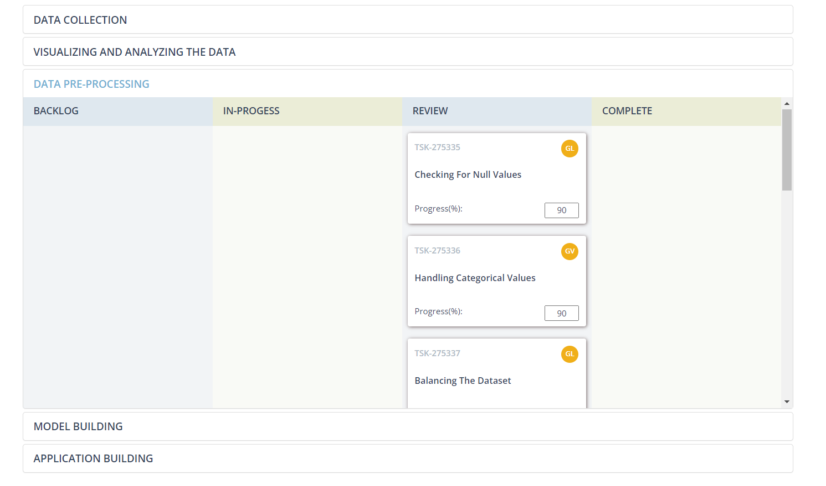Screenshots: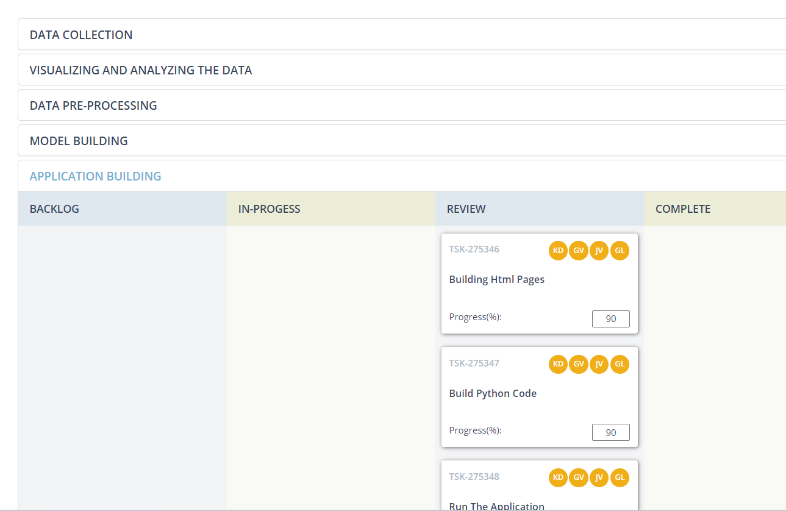

**3. Data Collection and Preprocessing Phase**

**3.1. Data Collection Plan and Raw Data Sources Identified**

|  |  |
| --- | --- |
| Date | 3 october 2024 |
| Team ID | LTVIP2024TMID24947 |
| Project Title | SmartLender - Applicant Credibility Prediction for Loan Approval |
| Maximum Marks | 2 Marks |

**Data Collection Plan & Raw Data Sources Identification Report:**

Elevate your data strategy with the Data Collection plan and the Raw Data Sources report, ensuring meticulous data curation and integrity for informed decision-making in every analysis and decision-making endeavor.

**Data Collection Plan:**

|  |  |
| --- | --- |
| **Section** | **Description** |
| Project Overview | The machine learning project **SmartLender** aims to solve this problem by providing an automated system that evaluates applicants based on multiple factors like their number of dependents, education level, employment status, loan amount, loan term, CIBIL score, and assets. This model will ensure fast, fair, and accurate loan approval decisions, helping both the lender and applicant experience a smoother loan approval process. |
| Data Collection Plan | * Search for datasets related to loan approvals, financial information, and applicant details. * Prioritize datasets with diverse demographic information. |
| Raw Data Sources Identified | The raw data sources for this project include datasets obtained from Kaggle the popular platforms for data science competitions and repositories. The provided sample data represents a subset of the collected information, encompassing variables such as their number of dependents, education level, employment status, loan amount, loan term, CIBIL score, and assets. |

|  |  |  |  |  |  |
| --- | --- | --- | --- | --- | --- |
| **Source Name** | **Description** | **Location/URL** | **Format** | **Size** | **Access Permissions** |
| Kaggle Dataset | The dataset comprises applicant details (gender, marital status), financial metrics (income, loan amount), and loan approval outcomes. | <https://www.kaggle.com/datasets/architsharma01/loan-approval-prediction-dataset/data> | CSV | 384 KB | Public |

**Raw Data Sources Report:**

**3.2. Data Quality Report**

|  |  |
| --- | --- |
| Date | 03 October 2024 |
| Team ID | LTVIP2024TMID24947 |
| Project Title | SmartLender - Applicant Credibility Prediction for Loan Approval |
| Maximum Marks | 2 Marks |

Data Quality Report:

The Data Quality Report will summarize data quality issues from the selected source, including severity levels and resolution plans. It will aid in systematically identifying and rectifying data discrepancies.

Data Quality Report:

|  |  |  |  |
| --- | --- | --- | --- |
| Data Source | Data Quality Issue | Severity | Resolution Plan |
| Kaggle Dataset | Categorical data in the dataset | Moderate | encoding has to be done in the data. |

**3.3. Data Exploration and Preprocessing**

|  |  |
| --- | --- |
| Date | 03 October 2024 |
| Team ID | LTVIP2024TMID24947 |
| Project Title | SmartLender - Applicant Credibility Prediction for Loan Approval |
| Maximum Marks | 6 Marks |

**Data Exploration and Preprocessing Report**

Dataset variables will be statistically analyzed to identify patterns and outliers, with Python

employed for preprocessing tasks like normalization and feature engineering. Data cleaning will address missing values and outliers, ensuring quality for subsequent analysis and modeling, and forming a strong foundation for insights and predictions.

|  |  |
| --- | --- |
| **Section** | **Description** |
| Data Overview | Dimension: 4269 rows × 12 columns  Descriptive statistics: |
| Univariate Analysis |  |

|  |  |
| --- | --- |
|  |  |
| Bivariate Analysis |  |
| Multivariate Analysis |  |

|  |  |
| --- | --- |
| Outliers and Anomalies | - |
| **Data Preprocessing Code Screenshots** | |
| Loading Data |  |
| Data Transformation |  |
| Balancing the data |  |
| Feature Engineering | Attached the codes in final submission. |
| Save Processed Data | - |

**4.Model Development Phase**

**4.1. Feature Selection Report**

|  |  |
| --- | --- |
| Date | 03 October 2024 |
| Team ID | LTVIP2024TMID24947 |
| Project Title | SmartLender - Applicant Credibility Prediction for Loan Approval |
| Maximum Marks | 5 Marks |

**Feature Selection Report Template**

In the forthcoming update, each feature will be accompanied by a brief description. Users will indicate whether it's selected or not, providing reasoning for their decision. This process will streamline decision-making and enhance transparency in feature selection.

|  |  |  |  |
| --- | --- | --- | --- |
| **Feature** | **Description** | **Selected (Yes/No)** | **Reasoning** |
| Loan_ID | Unique identifier for each loan applicant | No | For predicting the loan, a Loan ID is not required. |
| Dependents | Number of dependents | Yes | Indicates financial responsibilities and influences loan capacity. |
| Self_Employ ed | Self-employme nt status | Yes | Self-employed individuals may have different financial profiles. |
| Income in annum | Income of the applicant in a year | Yes | It is crucial in determining the applicant's financial capacity. |

|  |  |  |  |
| --- | --- | --- | --- |
| Loan Amount | Amount of loan applied | Yes | Fundamental for assessing the financial magnitude of the loan. |
| Loan Term | Term of the loan (in years) | Yes | The loan term influences monthly repayments and impacts eligibility. |
| Cibil score | Cibil score of the applicant | Yes | A major factor in loan approval is reflecting the applicant's creditworthiness. |
| Assets | Assets of applicant | Yes | It is crucial in determining the applicant's financial capacity. |
| Loan_Status | Loan approval outcome | Yes | The target variable for predictive modeling – is essential for the project's goal. |

**4.2. Model Selection Report**

|  |  |
| --- | --- |
| Date | 03 October 2024 |
| Team ID | LTVIP2024TMID24947 |
| Project Title | SmartLender - Applicant Credibility Prediction for Loan Approval |
| Maximum Marks | 6 Marks |

**Model Selection Report**

In the forthcoming Model Selection Report, various models will be outlined, detailing their descriptions, hyperparameters, and performance metrics, including Accuracy or F1 Score. This comprehensive report will provide insights into the chosen models and their effectiveness.

|  |  |  |  |
| --- | --- | --- | --- |
| **Model** | **Description** | **Hyperparameters** | **Performance Metric (e.g., Accuracy, F1 Score)** |
| Random Forest | Ensemble of decision trees; robust, handles complex relationships, reduces overfitting, and provides feature importance for loan approval prediction. | - | Accuracy score = 97% |
| Decision Tree | Simple tree structure; interpretable, captures non-linear relationships, suitable for initial insights into loan approval patterns. | - | Accuracy score = 91% |
| KNN | Classifies based on nearest neighbors; adapts well to data patterns, effective | - | Accuracy score = 96% |

|  |  |  |  |
| --- | --- | --- | --- |
|  | for local variations in loan approval criteria. |  |  |
| Xg boost  Gradient Boosting | Gradient boosting with trees; optimizes predictive performance, handles complex relationships, and is suitable for accurate loan approval predictions. | - | Accuracy score = 97% |

**4.3. Initial Model Training Code, Model Validation and Evaluation Report**

|  |  |
| --- | --- |
| Date | 03 October 2024 |
| Team ID | LTVIP2024TMID24947 |
| Project Title | SmartLender - Applicant Credibility Prediction for Loan Approval |
| Maximum Marks | 4 Marks |

**Initial Model Training Code, Model Validation and Evaluation Report**

The initial model training code will be showcased in the future through a screenshot.

The model validation and evaluation report will include classification reports, accuracy, and confusion matrices for multiple models, presented through respective screenshots.

**Initial Model Training Code:**

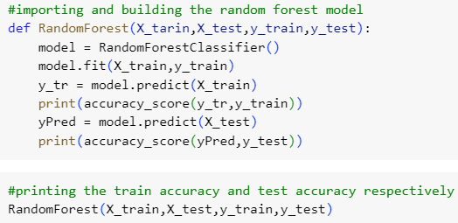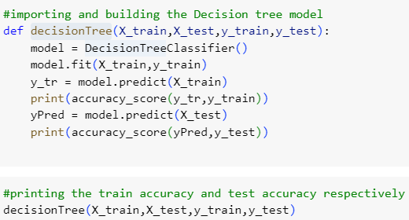

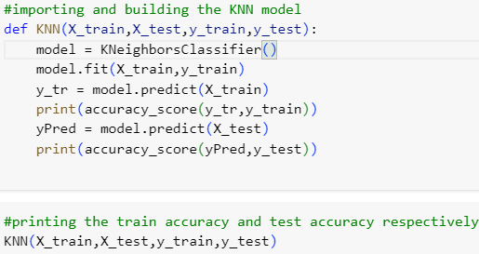



**Model Validation and Evaluaion Report:**

|  |  |  |  |
| --- | --- | --- | --- |
| **Model** | **Classification Report** | **F1**  **Scor e** | **Confusion Matrix** |
| Random Forest |  | 98% |  |
| Decision Tree |  | 98% |  |
| KNN |  | 92% |  |
| Gradient Boosting |  | 98% |  |

**5.Model Optimization and Tuning Phase**

**5.1. Hyperparameter Tuning Documentation**

|  |  |
| --- | --- |
| Date | 03 October 2024 |
| Team ID | LTVIP2024TMID24947 |
| Project Title | SmartLender - Applicant Credibility Prediction for Loan Approval |
| Maximum Marks | 10 Marks |

**Model Optimization and Tuning Phase**

The Model Optimization and Tuning Phase involves refining machine learning models for peak performance. It includes optimized model code, fine-tuning hyperparameters, comparing

performance metrics, and justifying the final model selection for enhanced predictive accuracy and efficiency.

**Hyperparameter Tuning Documentation (6 Marks):**

|  |  |  |
| --- | --- | --- |
| **Model** | **Tuned Hyperparameters** | **Optimal Values** |
| Decision Tree |  |  |
| Random Forest |  |  |

|  |  |  |
| --- | --- | --- |
| KNN |  |  |
| XG Boost |  |  |

**5.2 Performance Metrics Comparison Report:**

|  |  |
| --- | --- |
| **Model** | **Optimized Metric** |
| Decision Tree |  |

|  |  |
| --- | --- |
| Random Forest |  |
| KNN |  |
| XG Boost |  |

**5.3 Final Model Selection Justification:**

|  |  |
| --- | --- |
| **Final Model** | **Reasoning** |
| Random forest | After evaluating the models based on several metrics such as **accuracy**, **precision**, **recall**, and **F1-score**, all models demonstrated good performance. However, **Random Forest (RF)** was selected as the final model due to its combination of accuracy, robustness, and interpretability. While XGBoost showed competitive performance, RF was easier to interpret and required less computational overhead for deployment, making it more suitable for this application.  **Final Choice**: **Random Forest** was chosen as the model for predicting loan eligibility because of its high performance and the ability to generalize well to new, unseen data. |

6 . Results:

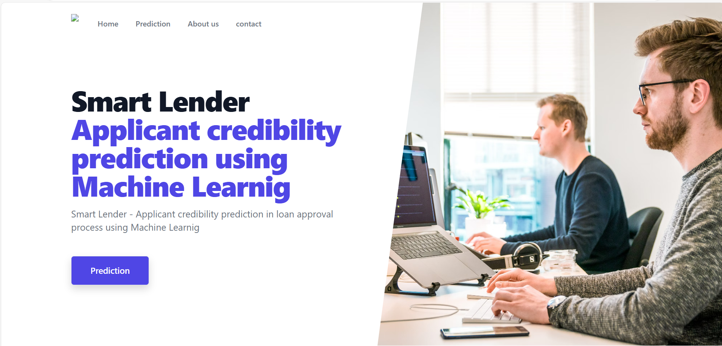 Output screens:

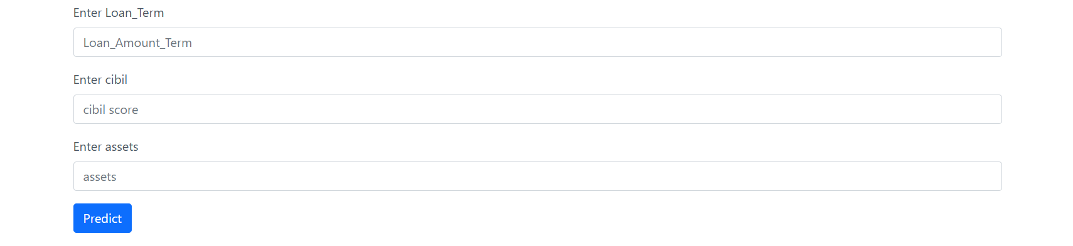 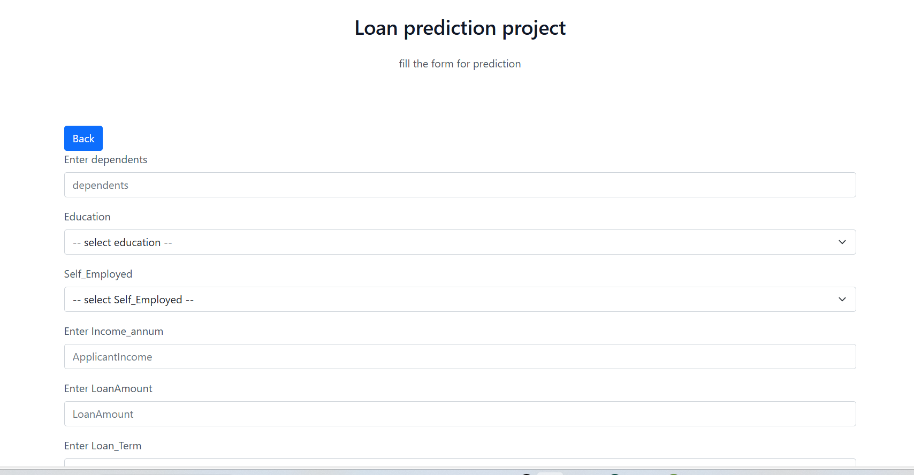

 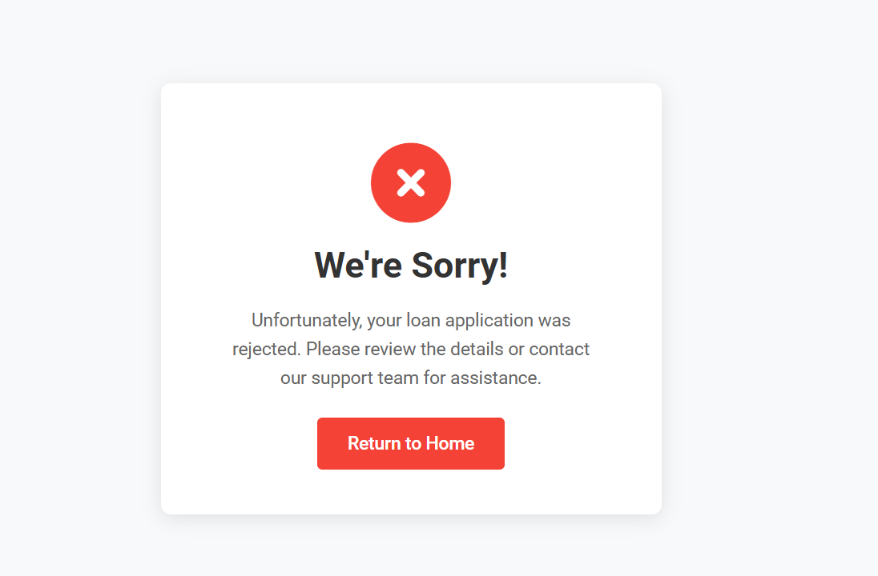

# pyNotebook output screens:

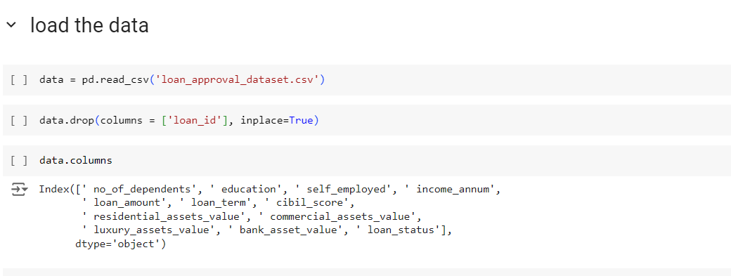

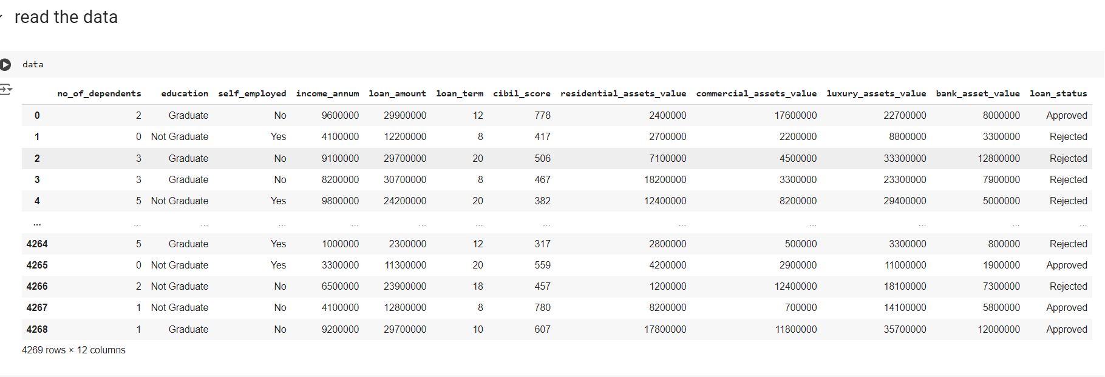

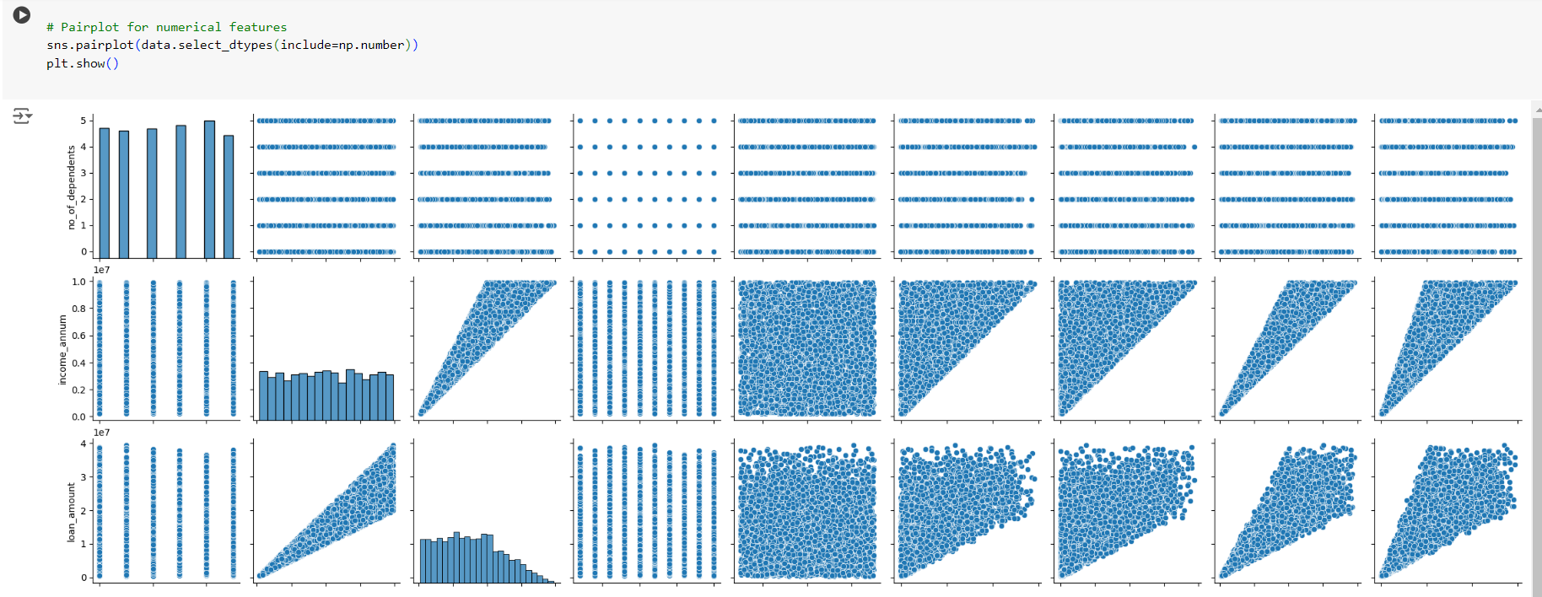

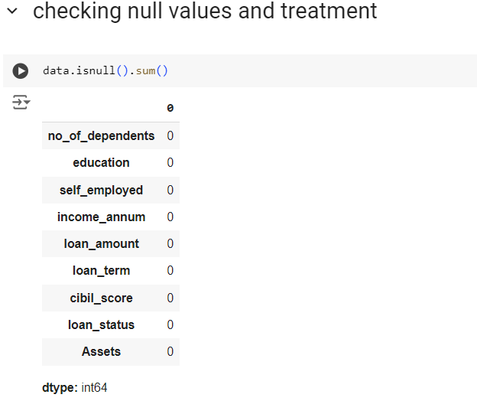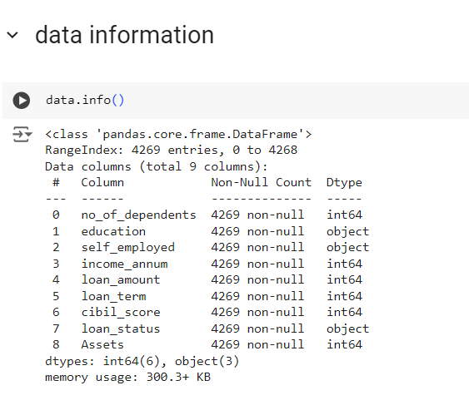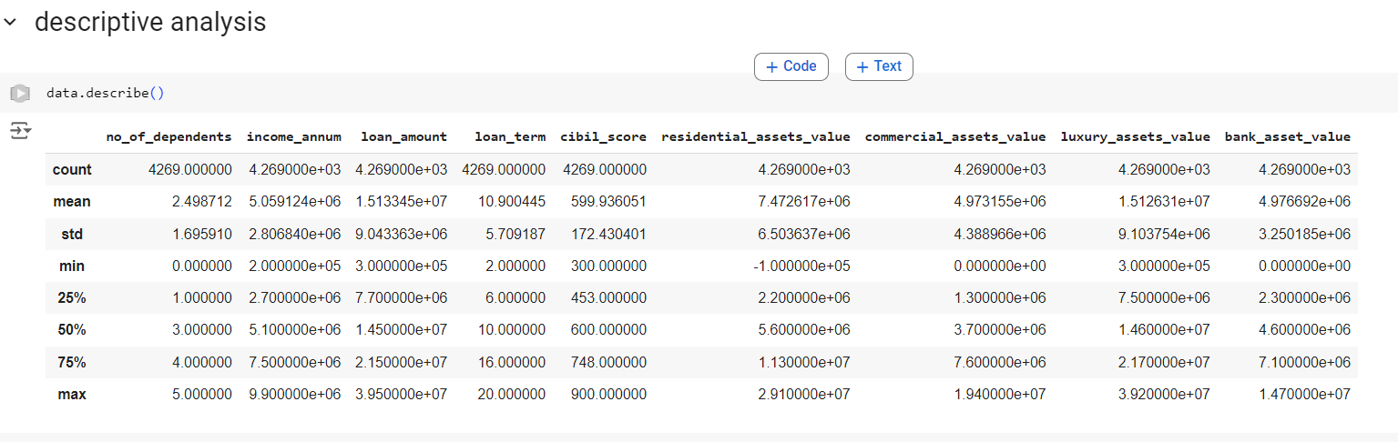

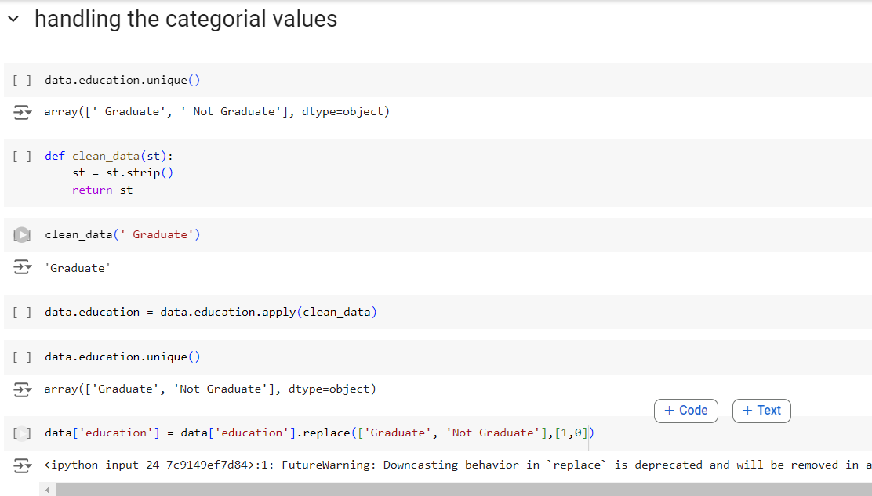

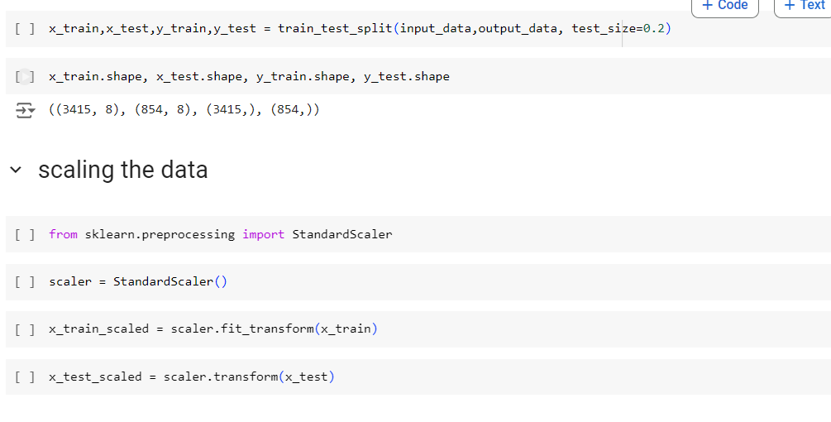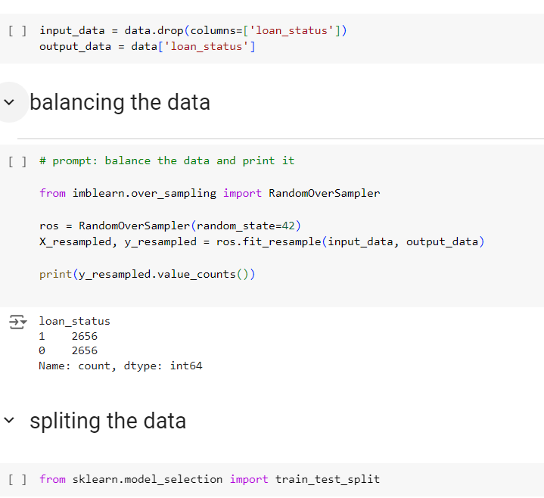

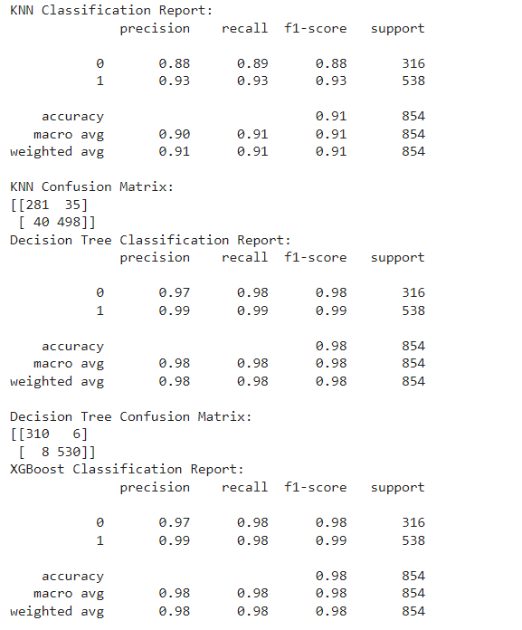

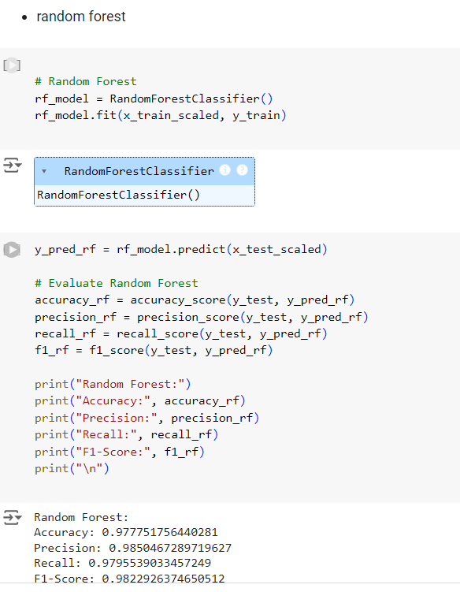

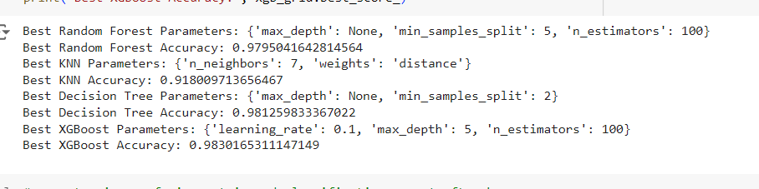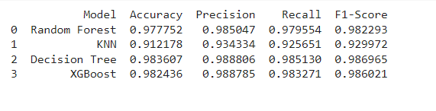

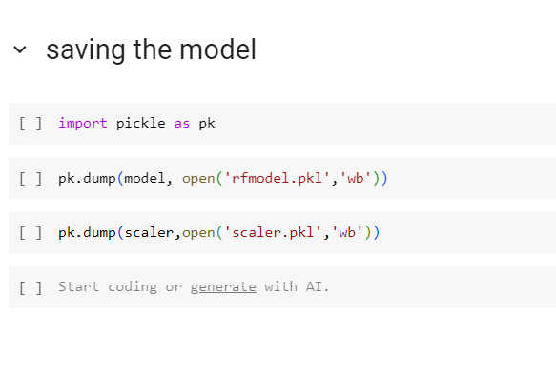**7. Advantages & Disadvantages**

* **Advantages:**
* **Efficiency**: The automated loan approval system streamlines decision-making, reducing the time required for manual reviews.
* **Accuracy**: Machine learning models provide data-driven decisions, minimizing human errors and biases.
* **Scalability**: The system can easily handle a large volume of loan applications without the need for proportional resource expansion.
* **Fairness**: Automated decision-making reduces the risk of biased outcomes, ensuring more fair assessments based on objective criteria.
* **Adaptability**: Continuous learning from new data allows the system to adapt to changing financial patterns and applicant profiles.

**Disadvantages:**

* **Data Dependency**: The model’s accuracy is heavily dependent on the quality and quantity of data, which may introduce biases if the data is unbalanced.
* **Model Interpretability**: Some machine learning models, especially complex ones like XGBoost, may lack transparency, making it difficult for stakeholders to understand decisions.
* **Costs**: Implementing and maintaining such a system, especially with hardware and computational needs, can incur significant costs.
* **Overfitting Risk**: There’s a possibility of models overfitting to training data, which can affect the generalization to unseen loan applicants.

**8. Conclusion**

* The SmartLender project demonstrates the potential of integrating machine learning into the loan approval process. By addressing the inefficiencies and inaccuracies of traditional manual reviews, SmartLender offers a solution that not only speeds up decision-making but also ensures more accurate and fair outcomes for applicants. The automated evaluation process will benefit both lenders and applicants, fostering a more streamlined and reliable loan approval process. As the project progresses, the continuous improvement of models and data quality will further enhance the system’s performance and adaptability in real-world scenarios.

**9. Future Scope**

SmartLender has a promising future with potential enhancements that can improve its effectiveness and applicability:

* **Incorporation of Additional Financial Metrics**: Future iterations of the model could include more detailed financial indicators like debt-to-income ratios, credit card histories, or previous loan repayments.
* **Expansion to Other Financial Services**: The same machine learning techniques could be adapted for use in insurance underwriting, credit card approvals, or mortgage lending.
* **Real-Time Data Integration**: The inclusion of real-time financial data feeds could allow for more dynamic loan approval decisions that account for market fluctuations.
* **Advanced Model Techniques**: Incorporating deep learning techniques or reinforcement learning could further boost the accuracy of creditworthiness predictions.
* **Ethical AI Practices**: Ongoing work should focus on ensuring the model adheres to ethical standards, addressing potential biases in the data and decision

# 10 . APPENDIX

10.1 source code:

App.py  
from markupsafe import escape

from flask import Flask, request, render_template,redirect,url_for

import pickle

import numpy as np

app = Flask(__name__)

model = pickle.load(open(r'rfmodel.pkl', 'rb'))

scaler = pickle.load(open(r'scaler.pkl', 'rb'))

# Define mapping dictionaries

education_mapping = {"Graduate": 0, "Not Graduate": 1}

employed_mapping = {"Yes": 1, "No": 0}

@app.route('/')

def home():

    return render_template("index.html")

@app.route('/predict', methods=['GET', 'POST'])

def predict():

    if request.method == 'POST':

        try:

            # Fetch input values from the form

            dependents = int(request.form['dependents'])

            education = request.form['education']

            employed = request.form['employed']

            income_annum = int(request.form['income_annum'])

            LoanAmount = int(request.form['LoanAmount'])

            Loan_Term = int(request.form['Loan_Term'])

            cibil = int(request.form['cibil'])

            assets = int(request.form['assets'])

            print(f"Dependents: {dependents}, Education: {education}, Employed: {employed}, "

                  f"Income Annum: {income_annum}, Loan Amount: {LoanAmount}, Loan Term: {Loan_Term}, "

                  f"CIBIL: {cibil}, Assets: {assets}")

            # Use predefined mappings for education and employment status

            grad_s = education_mapping.get(education, 1)

            emp_s = employed_mapping.get(employed, 0)

            # Prepare input data for the model

            data = [[dependents, grad_s, emp_s, income_annum, LoanAmount, Loan_Term, cibil, assets]]

            data = scaler.transform(data)  # Apply scaling

            # Make prediction

            prediction = model.predict(data)

            if prediction[0] == 1:

                return redirect(url_for('loan_approved'))

            else:

                return redirect(url_for('loan_rejected'))

        except KeyError as e:

            return f"KeyError: {str(e)}. Please check your form data.", 400

        except ValueError as e:

            return f"ValueError: {str(e)}. Please check your input values.", 400

        except Exception as e:

            return str(e), 400

    return render_template('prediction.html')

@app.route('/loan_approved')

def loan_approved():

    return render_template("approved.html")  # Create this template for approved loans

@app.route('/loan_rejected')

def loan_rejected():

    return render_template('rejected.html')  # Create this template for rejected loans

if __name__ == "__main__":

    app.run(debug=True)

# index.html

hh<!doctype html>

<html lang="en">

  <head>

    <!-- Required meta tags -->

    <meta charset="utf-8">

    <meta name="viewport" content="width=device-width, initial-scale=1">

    <!-- Bootstrap CSS -->

    <link href="https://cdn.jsdelivr.net/npm/bootstrap@5.0.0-beta3/dist/css/bootstrap.min.css" rel="stylesheet" integrity="sha384-eOJMYsd53ii+scO/bJGFsiCZc+5NDVN2yr8+0RDqr0Ql0h+rP48ckxlpbzKgwra6" crossorigin="anonymous">

    <link href="https://unpkg.com/tailwindcss@^2/dist/tailwind.min.css" rel="stylesheet">

    <title>loan Prediction</title>

  </head>

  <body>

<!-- This example requires Tailwind CSS v2.0+ -->

<div class="relative bg-white overflow-hidden">

  <div class="max-w-7xl mx-auto">

    <div class="relative z-10 pb-8 bg-white sm:pb-16 md:pb-20 lg:max-w-2xl lg:w-full lg:pb-28 xl:pb-32">

      <svg class="hidden lg:block absolute right-0 inset-y-0 h-full w-48 text-white transform translate-x-1/2" fill="currentColor" viewBox="0 0 100 100" preserveAspectRatio="none" aria-hidden="true">

        <polygon points="50,0 100,0 50,100 0,100" />

      </svg>

      <div class="relative pt-6 px-4 sm:px-6 lg:px-8">

        <nav class="relative flex items-center justify-between sm:h-10 lg:justify-start" aria-label="Global">

          <div class="flex items-center flex-grow flex-shrink-0 lg:flex-grow-0">

            <div class="flex items-center justify-between w-full md:w-auto">

              <a href="#">

                <span class="sr-only">Workflow</span>

                <img class="h-8 w-auto sm:h-10" src="https://tailwindui.com/img/logos/workflow-mark-indigo-600.svg">

              </a>

              <div class="-mr-2 flex items-center md:hidden">

                <button type="button" class="bg-white rounded-md p-2 inline-flex items-center justify-center text-gray-400 hover:text-gray-500 hover:bg-gray-100 focus:outline-none focus:ring-2 focus:ring-inset focus:ring-indigo-500" aria-expanded="false">

                  <span class="sr-only">Open main menu</span>

                  <!-- Heroicon name: outline/menu -->

                  <svg class="h-6 w-6" xmlns="http://www.w3.org/2000/svg" fill="none" viewBox="0 0 24 24" stroke="currentColor" aria-hidden="true">

                    <path stroke-linecap="round" stroke-linejoin="round" stroke-width="2" d="M4 6h16M4 12h16M4 18h16" />

                  </svg>

                </button>

              </div>

            </div>

          </div>

          <div class="hidden md:block md:ml-10 md:pr-4 md:space-x-8">

            <a href="#" class="font-medium text-gray-500 hover:text-gray-900">Home</a>

            <a href="#" class="font-medium text-gray-500 hover:text-gray-900">Prediction</a>

            <a href="#" class="font-medium text-gray-500 hover:text-gray-900">About us</a>

            <a href="#" class="font-medium text-gray-500 hover:text-gray-900">contact</a>

          </div>

        </nav>

      </div>

      <!--

        Mobile menu, show/hide based on menu open state.

        Entering: "duration-150 ease-out"

          From: "opacity-0 scale-95"

          To: "opacity-100 scale-100"

        Leaving: "duration-100 ease-in"

          From: "opacity-100 scale-100"

          To: "opacity-0 scale-95"

      -->

        <div class="absolute top-0 inset-x-0 p-2 transition transform origin-top-right md:hidden">

          <div class="rounded-lg shadow-md bg-white ring-1 ring-black ring-opacity-5 overflow-hidden">

            <div class="px-5 pt-4 flex items-center justify-between">

              <div>

                <img class="h-8 w-auto" src="https://tailwindui.com/img/logos/workflow-mark-indigo-600.svg" alt="">

              </div>

              <div class="-mr-2">

                <button type="button" class="bg-white rounded-md p-2 inline-flex items-center justify-center text-gray-400 hover:text-gray-500 hover:bg-gray-100 focus:outline-none focus:ring-2 focus:ring-inset focus:ring-indigo-500">

                  <span class="sr-only">Close main menu</span>

                  <!-- Heroicon name: outline/x -->

                  <svg class="h-6 w-6" xmlns="http://www.w3.org/2000/svg" fill="none" viewBox="0 0 24 24" stroke="currentColor" aria-hidden="true">

                    <path stroke-linecap="round" stroke-linejoin="round" stroke-width="2" d="M6 18L18 6M6 6l12 12" />

                  </svg>

                </button>

              </div>

            </div>

          <div class="px-2 pt-2 pb-3 space-y-1">

            <a href="#" class="block px-3 py-2 rounded-md text-base font-medium text-gray-700 hover:text-gray-900 hover:bg-gray-50">Home</a>

            <a href="#" class="block px-3 py-2 rounded-md text-base font-medium text-gray-700 hover:text-gray-900 hover:bg-gray-50">prediction</a>

            <a href="#" class="block px-3 py-2 rounded-md text-base font-medium text-gray-700 hover:text-gray-900 hover:bg-gray-50">about us</a>

            <a href="#" class="block px-3 py-2 rounded-md text-base font-medium text-gray-700 hover:text-gray-900 hover:bg-gray-50">contact</a>

          </div>

        </div>

      </div>

      <main class="mt-10 mx-auto max-w-7xl px-4 sm:mt-12 sm:px-6 md:mt-16 lg:mt-20 lg:px-8 xl:mt-28">

        <div class="sm:text-center lg:text-left">

          <h1 class="text-4xl tracking-tight font-extrabold text-gray-900 sm:text-5xl md:text-6xl">

            <span class="block xl:inline">Smart Lender</span>

            <span class="block text-indigo-600 xl:inline"> Applicant credibility prediction using Machine Learnig </span>

          </h1>

          <p class="mt-3 text-base text-gray-500 sm:mt-5 sm:text-lg sm:max-w-xl sm:mx-auto md:mt-5 md:text-xl lg:mx-0">

            Smart Lender - Applicant credibility prediction in loan approval process using Machine Learnig

          </p>

          <div class="mt-5 sm:mt-8 sm:flex sm:justify-center lg:justify-start">

            <div class="rounded-md shadow">

              <a href="./predict" class="w-full flex items-center justify-center px-8 py-3 border border-transparent text-base font-medium rounded-md text-white bg-indigo-600 hover:bg-indigo-700 md:py-4 md:text-lg md:px-10">

                Prediction

              </a>

            </div>

          </div>

        </div>

      </main>

    </div>

  </div>

  <div class="lg:absolute lg:inset-y-0 lg:right-0 lg:w-1/2">

    <img class="h-56 w-full object-cover sm:h-72 md:h-96 lg:w-full lg:h-full" src="https://images.unsplash.com/photo-1551434678-e076c223a692?ixlib=rb-1.2.1&ixid=eyJhcHBfaWQiOjEyMDd9&auto=format&fit=crop&w=2850&q=80" alt="">

  </div>

</div>

    <!-- Option 1: Bootstrap Bundle with Popper -->

    <script src="https://cdn.jsdelivr.net/npm/bootstrap@5.0.0-beta3/dist/js/bootstrap.bundle.min.js" integrity="sha384-JEW9xMcG8R+pH31jmWH6WWP0WintQrMb4s7ZOdauHnUtxwoG2vI5DkLtS3qm9Ekf" crossorigin="anonymous"></script>

  </body>

</html>

#Prediction.html

hhh<!doctype html>

<html lang="en">

  <head>

    <!-- Required meta tags -->

    <meta charset="utf-8">

    <meta name="viewport" content="width=device-width, initial-scale=1">

    <!-- Bootstrap CSS -->

    <link href="https://cdn.jsdelivr.net/npm/bootstrap@5.0.0-beta3/dist/css/bootstrap.min.css" rel="stylesheet" integrity="sha384-eOJMYsd53ii+scO/bJGFsiCZc+5NDVN2yr8+0RDqr0Ql0h+rP48ckxlpbzKgwra6" crossorigin="anonymous">

    <link href="https://unpkg.com/tailwindcss@^2/dist/tailwind.min.css" rel="stylesheet">

    <title>loan Prediction</title>

  </head>

  <body>

<!-- This example requires Tailwind CSS v2.0+ -->

<div class="relative bg-white overflow-hidden">

  <div class="max-w-7xl mx-auto">

    <div class="relative z-10 pb-8 bg-white sm:pb-16 md:pb-20 lg:max-w-2xl lg:w-full lg:pb-28 xl:pb-32">

      <svg class="hidden lg:block absolute right-0 inset-y-0 h-full w-48 text-white transform translate-x-1/2" fill="currentColor" viewBox="0 0 100 100" preserveAspectRatio="none" aria-hidden="true">

        <polygon points="50,0 100,0 50,100 0,100" />

      </svg>

      <div class="relative pt-6 px-4 sm:px-6 lg:px-8">

        <nav class="relative flex items-center justify-between sm:h-10 lg:justify-start" aria-label="Global">

          <div class="flex items-center flex-grow flex-shrink-0 lg:flex-grow-0">

            <div class="flex items-center justify-between w-full md:w-auto">

              <a href="#">

                <span class="sr-only">Workflow</span>

                <img class="h-8 w-auto sm:h-10" src="https://tailwindui.com/img/logos/workflow-mark-indigo-600.svg">

              </a>

              <div class="-mr-2 flex items-center md:hidden">

                <button type="button" class="bg-white rounded-md p-2 inline-flex items-center justify-center text-gray-400 hover:text-gray-500 hover:bg-gray-100 focus:outline-none focus:ring-2 focus:ring-inset focus:ring-indigo-500" aria-expanded="false">

                  <span class="sr-only">Open main menu</span>

                  <!-- Heroicon name: outline/menu -->

                  <svg class="h-6 w-6" xmlns="http://www.w3.org/2000/svg" fill="none" viewBox="0 0 24 24" stroke="currentColor" aria-hidden="true">

                    <path stroke-linecap="round" stroke-linejoin="round" stroke-width="2" d="M4 6h16M4 12h16M4 18h16" />

                  </svg>

                </button>

              </div>

            </div>

          </div>

          <div class="hidden md:block md:ml-10 md:pr-4 md:space-x-8">

            <a href="#" class="font-medium text-gray-500 hover:text-gray-900">Home</a>

            <a href="#" class="font-medium text-gray-500 hover:text-gray-900">Prediction</a>

            <a href="#" class="font-medium text-gray-500 hover:text-gray-900">About us</a>

            <a href="#" class="font-medium text-gray-500 hover:text-gray-900">contact</a>

          </div>

        </nav>

      </div>

      <!--

        Mobile menu, show/hide based on menu open state.

        Entering: "duration-150 ease-out"

          From: "opacity-0 scale-95"

          To: "opacity-100 scale-100"

        Leaving: "duration-100 ease-in"

          From: "opacity-100 scale-100"

          To: "opacity-0 scale-95"

      -->

        <div class="absolute top-0 inset-x-0 p-2 transition transform origin-top-right md:hidden">

          <div class="rounded-lg shadow-md bg-white ring-1 ring-black ring-opacity-5 overflow-hidden">

            <div class="px-5 pt-4 flex items-center justify-between">

              <div>

                <img class="h-8 w-auto" src="https://tailwindui.com/img/logos/workflow-mark-indigo-600.svg" alt="">

              </div>

              <div class="-mr-2">

                <button type="button" class="bg-white rounded-md p-2 inline-flex items-center justify-center text-gray-400 hover:text-gray-500 hover:bg-gray-100 focus:outline-none focus:ring-2 focus:ring-inset focus:ring-indigo-500">

                  <span class="sr-only">Close main menu</span>

                  <!-- Heroicon name: outline/x -->

                  <svg class="h-6 w-6" xmlns="http://www.w3.org/2000/svg" fill="none" viewBox="0 0 24 24" stroke="currentColor" aria-hidden="true">

                    <path stroke-linecap="round" stroke-linejoin="round" stroke-width="2" d="M6 18L18 6M6 6l12 12" />

                  </svg>

                </button>

              </div>

            </div>

          <div class="px-2 pt-2 pb-3 space-y-1">

            <a href="#" class="block px-3 py-2 rounded-md text-base font-medium text-gray-700 hover:text-gray-900 hover:bg-gray-50">Home</a>

            <a href="#" class="block px-3 py-2 rounded-md text-base font-medium text-gray-700 hover:text-gray-900 hover:bg-gray-50">prediction</a>

            <a href="#" class="block px-3 py-2 rounded-md text-base font-medium text-gray-700 hover:text-gray-900 hover:bg-gray-50">about us</a>

            <a href="#" class="block px-3 py-2 rounded-md text-base font-medium text-gray-700 hover:text-gray-900 hover:bg-gray-50">contact</a>

          </div>

        </div>

      </div>

      <main class="mt-10 mx-auto max-w-7xl px-4 sm:mt-12 sm:px-6 md:mt-16 lg:mt-20 lg:px-8 xl:mt-28">

        <div class="sm:text-center lg:text-left">

          <h1 class="text-4xl tracking-tight font-extrabold text-gray-900 sm:text-5xl md:text-6xl">

            <span class="block xl:inline">Smart Lender</span>

            <span class="block text-indigo-600 xl:inline"> Applicant credibility prediction using Machine Learnig </span>

          </h1>

          <p class="mt-3 text-base text-gray-500 sm:mt-5 sm:text-lg sm:max-w-xl sm:mx-auto md:mt-5 md:text-xl lg:mx-0">

            Smart Lender - Applicant credibility prediction in loan approval process using Machine Learnig

          </p>

          <div class="mt-5 sm:mt-8 sm:flex sm:justify-center lg:justify-start">

            <div class="rounded-md shadow">

              <a href="./predict" class="w-full flex items-center justify-center px-8 py-3 border border-transparent text-base font-medium rounded-md text-white bg-indigo-600 hover:bg-indigo-700 md:py-4 md:text-lg md:px-10">

                Prediction

              </a>

            </div>

          </div>

        </div>

      </main>

    </div>

  </div>

  <div class="lg:absolute lg:inset-y-0 lg:right-0 lg:w-1/2">

    <img class="h-56 w-full object-cover sm:h-72 md:h-96 lg:w-full lg:h-full" src="https://images.unsplash.com/photo-1551434678-e076c223a692?ixlib=rb-1.2.1&ixid=eyJhcHBfaWQiOjEyMDd9&auto=format&fit=crop&w=2850&q=80" alt="">

  </div>

</div>

    <!-- Option 1: Bootstrap Bundle with Popper -->

    <script src="https://cdn.jsdelivr.net/npm/bootstrap@5.0.0-beta3/dist/js/bootstrap.bundle.min.js" integrity="sha384-JEW9xMcG8R+pH31jmWH6WWP0WintQrMb4s7ZOdauHnUtxwoG2vI5DkLtS3qm9Ekf" crossorigin="anonymous"></script>

  </body>

</html>

#rejected.html  
<!DOCTYPE html>

<html lang="en">

<head>

    <meta charset="UTF-8">

    <meta name="viewport" content="width=device-width, initial-scale=1.0">

    <title>Loan Rejected</title>

    <link href="https://fonts.googleapis.com/css2?family=Roboto:wght@400;500;700&display=swap" rel="stylesheet">

    <link rel="stylesheet" href="https://cdnjs.cloudflare.com/ajax/libs/font-awesome/6.0.0-beta3/css/all.min.css">

    <style>

        /* Inline CSS */

        * {

            margin: 0;

            padding: 0;

            box-sizing: border-box;

        }

        body {

            font-family: 'Roboto', sans-serif;

            background-color: #f8f9fa;

            height: 100vh;

            display: flex;

            justify-content: center;

            align-items: center;

        }

        .container {

            background-color: white;

            box-shadow: 0px 4px 20px rgba(0, 0, 0, 0.1);

            border-radius: 10px;

            padding: 40px;

            text-align: center;

            width: 90%;

            max-width: 500px;

        }

        .content {

            padding: 20px;

        }

        .icon {

            font-size: 80px;

            color: #f44336;

            margin-bottom: 20px;

        }

        h1 {

            font-size: 36px;

            font-weight: 700;

            color: #333;

            margin-bottom: 20px;

        }

        p {

            font-size: 18px;

            font-weight: 400;

            color: #666;

            margin-bottom: 40px;

            line-height: 1.6;

        }

        .button {

            background-color: #f44336;

            color: white;

            text-decoration: none;

            padding: 15px 30px;

            border-radius: 5px;

            font-size: 18px;

            font-weight: 500;

            transition: background-color 0.3s ease;

        }

        .button:hover {

            background-color: #e53935;

        }

        @media (max-width: 600px) {

            .icon {

                font-size: 60px;

            }

            h1 {

                font-size: 28px;

            }

            p {

                font-size: 16px;

            }

            .button {

                font-size: 16px;

                padding: 12px 25px;

            }

        }

    </style>

</head>

<body>

    <div class="container">

        <div class="content">

            <i class="fas fa-times-circle icon"></i>

            <h1>We're Sorry!</h1>

            <p>Unfortunately, your loan application was rejected. Please review the details or contact our support team for assistance.</p>

            <a href="/" class="button">Return to Home</a>

        </div>

    </div>

</body>

</html>

10.2 github link:

[GitHub - NIVAS523/-Smart-Lender-Applicant-Credibility-Prediction-for-Loan-Approval-](https://github.com/NIVAS523/-Smart-Lender-Applicant-Credibility-Prediction-for-Loan-Approval-)